Setting us free?
Making Progression & Assessment Meaningful in a Post-Levels World
Alex Ford
With the demise of National Curriculum Levels, departments are now grappling with the issue of how they respond to the new freedoms to design their own assessment system. This session looks at why keeping the current system of Levels might end up being a retrograde step and gives some outline ideas for how we might develop more meaningful systems of assessment and progression.

Inspiration
- Teaching History: http://www.history.org.uk/resources/secondary_resources_12.html
- Schools History Project: http://www.schoolshistoryproject.org.uk
- Historical Thinking Project: http://historicalthinking.ca
- Stanford History Education Group: http://sheg.stanford.edu

- Counsell, C., 2000. 'Didn't we do that in Year 7? Planning for progress in evidential understanding. Teaching History, Issue 99, pp. 36-41.
- Lee, P. & Shemilt, D., 2003. A scaffold not a cage: progression and progression models in history.. Teaching History, Issue 113, pp. 13-23.
- Lee, P. & Shemilt, D., 2004. Progression in Understanding About Historical Accounts. Teaching History, Issue 117, pp. 25-31.
- Morton, T. & Seixas, P., 2012. The Big Six Historical Thinking Concepts. Toronto: Nelson Education.
- White, R., 1998. Remembering Ahanagran: story telling in a family's past. New York: Hill & Wang.
- Wineburg, S., 1999. Historical thinking and other unnatural acts. Phi Delta Kappan, 80(7), pp. 488-499.
- Wineburg, S., 2007. Unnatural and essential: the nature of historical thinking. Teaching History, Issue 129, pp. 6-11.

Discussion and Debate
I have set up a blog to discussion progress, progression and the new Key Stage 3 on www.andallthat.co.uk/blog. I am also happy to receive any submissions by email at apf102@googlemail.com

Key Question 2 | Why did William win the Battle of Hastings? (5 lessons)
Target Concepts | LO1 – Causation; LO2 – Historical Evidence; LO6 – Knowledge & Communication
Aim for the end of the enquiry | By the end of this question students should have a clear understanding of the main events of the Battle of Hastings, as well as an appreciation of why the Normans were victorious. They should have a grasp of the key events which turned the battle in William’s favour. In addition to the substantive concepts, this unit aims to serve as an introduction to historical essay writing. Students should be taught to communicate ideas about historical causation, considering the impact of multiple factors on the outcome of events, as well as looking at the impact of individual actions and impersonal, contextual factors.
Core Content |  | Assessment
- Who the Normans were  - England’s preparedness for invasion  - The invasion of Harald Hardraada and the Battle of Stamford Bridge and its impact  - The Bayeux tapestry as a source on the Norman battle  - William’s preparations for invasion and their impact  - The events of the Battle of Hastings  - Battlefield positions; William’s tactics – use of cavalry & archers; Harold’s tactics – shield wall, Housecarls; William’s ‘death’ Harold’s death, the defeat of the English  - The immediate aftermath of the battle  - Destruction of the English resistance, mutilation of bodies etc. |  | FORMAL ESSAY ASSESSMENT (2000 pts)  In class essay task: “Why did William win the Battle of Hastings?”  1 lesson should be spent planning the essay and another lesson writing up in controlled conditions.  Students need to answer the question with a focus on causal reasoning: LO 1.1; LO 1.2 and LO 1.3 as well as knowledge and communication LO 6.1; LO 6.2 and LO 6.3  Full essay task and mark scheme will be available on the staff drive  FEEDBACK  Students should have formal, comment-based, responsive feedback.  Effort: =unacceptable, =poor, =below par, =good, =v good  Progress mark:. (+) Making Progress; (=) Staying put (-) Going backwards!  Mastery Points: They should also be given a Mastery Points mark (0-2000 pts) taken from the mark scheme. This should be recorded in their books.

Key Question 3 | How far did the Normans change England?
Target Concepts | LO2 – Historical Evidence; LO4 – Change & Continuity; LO6 – Knowledge & Communication
Aim for the end of the enquiry | This key question aims to get students thinking beyond the conquest itself and considering instead IF and WHY it matters. Students will look at different changes the Normans tried to bring to England and then make a judgement about the PACE and EXTENT of change the Normans brought. This is a great opportunity for students to see how the power structure in England was changed and the impact this had on ordinary people. It is also a good point to explore how some groups resisted the Normans for this exact reason – a nice link into issues of power and control. Finally students should also have some appreciation that many things in England did not change and that some Anglo-Saxon customs and influences continued. There may be some great opportunities to use sources such as the Anglo-Saxon chronicle here too.
Core Content |  | Assessment
- Issues faced by William after the Battle of Hastings  - Control of regions; rebellions; threats of invasion lack of resources  - Attacks on the population  - Harrying of the North; crushing rebellions eg. Hereward the Wake  - Political changes  - Governance before the Normans; The feudal system – removing the Anglo-Saxon aristocracy; land redistribution; taxation and Domesday  - Social Changes  - Anglo Saxon language & culture; Norman changes to language – impact on names etc.  - Physical changes  - Anglo Saxon towns before the Normans; Impact of building castles and cathedrals – building of abbeys etc.; Merging of Anglo-Saxon and Norman culture – evident in church decoration. |  | INFORMAL ASSESSMENT  In-class/homework assessment – Prepare a TV programme which covers the impact of the Normans on England  - Focus on 3 key issues from the ones covered  - Script in groups and then record or present  - Needs to cover the PACE and EXTENT of the change the Normans brought  FEEDBACK  Comment marking and effort grade as part of normal marking cycle eg.  =unacceptable, =poor, =below par, =good, =v good  Progress mark ie. (+) Making Progress; (=) Staying put (-) Going backwards!

History Common Assessment
2000 pts
Title: Why did William Win the Battle of Hastings?

This assessment is testing your ability to explain things clearly, using the evidence you have prepared. You will have a lesson to gather your thoughts and make a plan and then another lesson to write your ideas up. There are 2000 Mastery Points up for grabs on this assessment. Most of you should be aiming for between 700 and 1300 pts.

The assessment is testing 3 really important skills in History
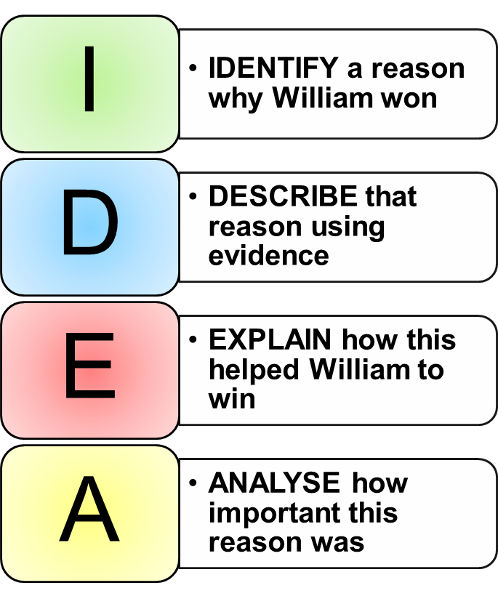
- Using your historical knowledge (LO6)
  - TIP: Make sure you know what happened at the Battle & can give specific examples.
- Explaining why things happened (LO1)
  - TIP: Remember that there are many different reasons or causes for William winning the battle – try to find the connections between them, or explain why some are more important than others.
- Writing in a clear way (LO6)
  - TIP: Remember to write in paragraphs, have an introduction which gives the background to the battle, and a conclusion which explains your overall opinion. Use the IDEA structure to help you structure your paragraphs.

Word Bank | Sentence starters
battle  cavalry  Harold Godwinson  Housecarls  leadership  Senlac Hill  William of Normandy | The Battle of Hastings happened in… when…  This essay will explain why…  There are many reasons why…  One reason that William won at Hastings is…  For example he…  …helped him win because…  If this had not happened…  Another reason why William defeated Harold…  If it had not been for…  The most important reason for William’s victory…  …is the most important reason because…  This links to…

History Common Assessment Feedback
Summary
Success | Challenge

Grade | Points Earned | Effort

You now need to respond to the feedback you have been given. This is a very important part of developing your understanding of history and making progress.

Teacher Notes
The table below shows how the points achieved by the student will translate into expectations for this Year 7 task.
0-500pts | Fail
A minority of students | Students at this level will tend to produce work which contains limited knowledge of the actions of William or of the events leading up to or during the Battle. Knowledge will be asserted where available and there may be inaccuracies in the knowledge given. In other cases, the knowledge used may be generic rather than specific eg. William played a trick on Harold…  The structure will tend to be narrative. Command of language will be weak.
600-900pts | Pass
Some students | Students at this level will show at least some knowledge of actions taken during the Battle of Hastings. Students may well give descriptions of the actions of William or the failures of Harold with some supporting detail. Knowledge will be relevant and accurate for the most part. They may also show some outline knowledge of the context of the battle.  The structure will still tend towards narrative, although some paragraphing may be evident thanks to the planning frame. Links back to the question will be implicit at best. There will be some evidence that the student understands at least the main outlines of the Battle of Hastings.
1000-1300pts | Merit
The vast majority of students | Students at this level will have a good understanding of the main events of the battle including some specific detail on the actions of William and of other factors leading to the victory. Evidence will be chosen to answer the question and there will be signs that there is a rationale to the choice of evidence. The accuracy of evidence will be generally good. There may be a stronger sense that students understand the context of the battle.  There will be a logical structure to the work, with key topics forming paragraphs and some conclusion, even if only short, being arrived at. The explanations given in paragraphs may still be implicit in their links to the question, however the conclusion will make an attempt to provide a direct answer to the question. Command of language will be adequate.
1400-1500pts | Distinction
A minority of students | Students at this level will tend to show a very good understanding of the battle – including specific details of the different contributing factors to William’s victory. There will be a rationale evident for the choice of evidence which will be deployed in a way which helps their argument. Analysis of this evidence may still lack depth however there will be obvious attempts to use the evidence to directly answer the question.  The structure of the essay will be largely analytical with a focus on the question which is sustained for the majority of the time. The account will show a deliberate engagement with the question and the conclusion will show an independent reflection on the question itself. At this level, students may also begin to consider the impact of different causes and see links between them. Command of language will be good.
1600-2000pts | Starred Distinction
Exceptionally rare | Student at this level produce a sustained and well-focused answer which is analytical. The answer will use a range of specific and accurate evidence to explore the importance of different factors in leading to William’s victory. There may still be some limitations to the analysis but the conclusions will demonstrate clear, justifiable and independent thinking and a good command of language.
Please ensure:
- You make a note of the points, grade and effort in your own mark book
- The student sticks in the marking proforma
- The student responds to the comments and corrections
- The student adds their points to their totaliser which is in the back of their book

Knowledge (LO 6.1)
Limited | 0-100pts | Students make limited reference to specific details or use details in a generic way. There is no real knowledge shown of specific actions or events which led to William’s victory. There may be some inaccuracies in knowledge which is used. | F
Beginning | 200pts | Students demonstrate some knowledge of the tactics used by William or the failures of Harold. They may refer to things they did in generalised ways rather than being specific. There may still be some inaccuracies in the knowledge used. | P
Sound | 300-400pts | Students show specific knowledge and understanding of one or more of the following: William’s specific tactics, Harold’s mistakes, the context leading to the battle. | M
Secure | 500-600pts | Students show a sound understanding of the main areas: William’s specific tactics, Harold’s mistakes, and the context leading to the battle. They give specific evidence which shows signs of selection. The evidence helps to create a convincing answer. | D/S
Argument and Communication (LO 6.2 & LO 6.3)
Limited | 100pts | Students make an effort to answer the question set by writing about at least some relevant information. The structure here will probably be a simple narrative covering what happened in some part of the battle. | F
Beginning | 200-300pts | There is evidence that students have tried to answer the question set. They generally describe the events of the battle but they do this using relevant knowledge. At the bottom of the level there might be little attempt to provide a structure. At the top of the level students might attempt to group their ideas more clearly | F/P
Sound | 400-500pts | Students use paragraphs to structure their thinking. They support their argument with evidence. At the bottom of the level, students might leave the links to the question fairly implicit, however there will be some explanation of the reasons why William won, even if this is only at the end. At the top of the level, students show evidence of a PEEL/IDEA structure with links back to the question being made. | P/M
Secure | 600pts | Student produce an analytical piece based around the key factors leading to William’s victory. They use a good range of evidence to back up their points, showing a good command of the topic. They explain their evidence and make links back to the question. The PEEL/IDEA structure is used well. | D/S
Making Causal Webs (LO 1.1)
Limited | 0pts | There is no real explanation offered of why William won the Battle either in the main body or in conclusion. | F
Beginning | 100-200pts | Students identify some reasons why William won the Battle of Hastings though the links between these and his victory are only partially explained or left implicit. A narrative with implied causation would fit in this band. | P/M
Sound | 300-400pts | Students identify at least 3 reasons why William won the Battle of Hastings and explain how at least two of these led to his victory. Explanations make a link back to the question. At the top of the level the analysis is clear and leads towards a conclusion. | M/D
Secure | 500pts | Students identify and explain at least 3 different reasons why William won the Battle of Hasting. They show how these link together to explain William’s victory | S
Ranking the Influence of Causes (LO 1.2)
Limited | 0pts | Students make no real reference to the importance of different causes that some causes had more importance than others in William defeating Harold. | F/P
Beginning | 100pts | Student make some reference to the importance of different causes in William’s victory. The judgement will not be fully supported or explained. | M
Sound | 200pts | Students explain why at least one factor was more important than others in William’s victory. | D
Secure | 300pts | Students show clear independent thought and judgement in considering the different causes of William’s victory. They show the importance of each factor in leading to William’s victory and appreciate the interconnected nature of causes. | S

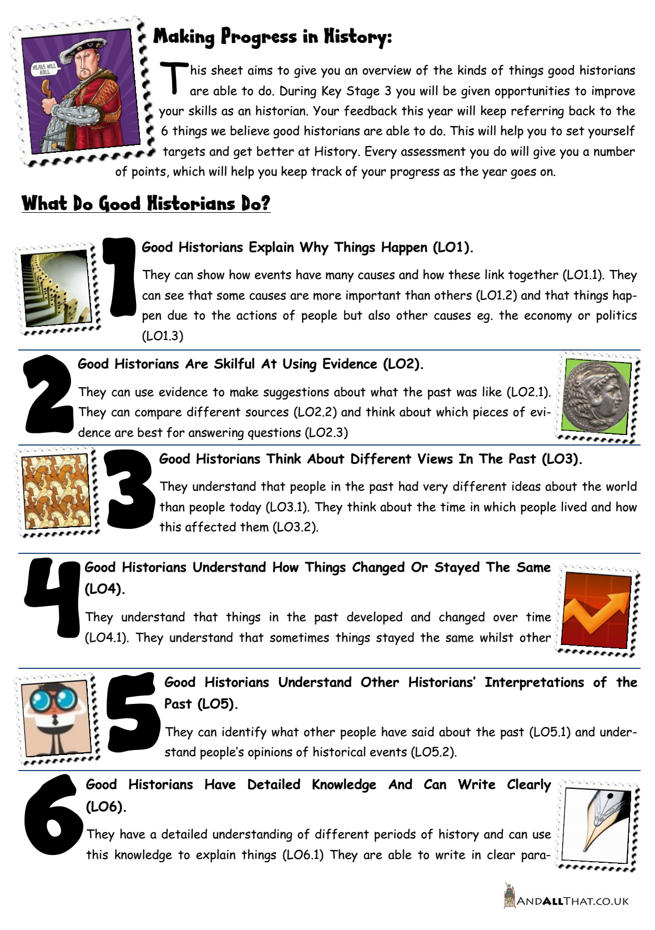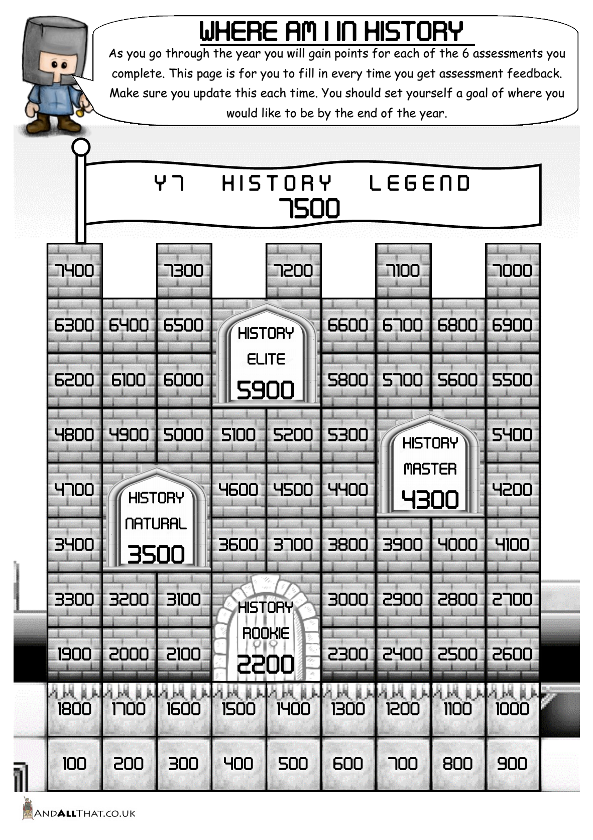

A Mastery Model for Historical Progression

Introduction
“As part of our reforms to the national curriculum , the current system of ‘levels’ used to report children’s attainment and progress will be removed. It will not be replaced.” (DfE, 2013)
Surely I cannot be the only one whose heart leapt when I read this statement in the DfE’s recent statement on assessment without National Curriculum Levels. In two short paragraphs, the document went on to describe everything that was wrong with the current system of assessment in Key Stages 1 to 3.
“We believe this system is complicated and difficult to understand, especially for parents. It also encourages teachers to focus on a pupil’s current level, rather than consider more broadly what the pupil can actually do. Prescribing a single detailed approach to assessment does not fit with the curriculum freedoms we are giving schools.” (DfE, 2013)
It has long been accepted that the system of NC Levels is woefully inadequate when it comes to describing, assessing or planning for progression in History. Levels have become, in the worst cases, the end point of teaching itself. This has been accompanied by an increasing fetishisation of NC Levels as a means of describing the progress of students in schools. Worryingly, the idea of NC Levels seems to have become so engrained that many are unsure how we assess now these ‘ladders’ have been removed. I would suggest however that this is a moment where we need to seize the opportunity to build meaningful models of progression with both hands.

Some Definitions
Before we progress, we need to clear up some definitions which have become somewhat blurred in Ofsted speak over the years.
Attainment - a measure of understanding at a particular point or in a particular assessment (for example an end of unit test, an end of lesson assessment, an end of year exam etc.). NC Levels were always intended as best-fit end of Key Stage measures of attainment. Attainment is effectively a summative mark (ie. a grade A*-E, Fail, Pass, Merit, Distinction etc.)
Progress - a moving measure over time. This is a holistic measure which should DESCRIBE how well a child's abilities, knowledge, understanding etc. have developed. Therefore progress cannot be pinpointed with a grade, it must be described as a process ie. is the progress slow, good, rapid etc? Of course the oversimplification with KS3 Levels has come because progress has been defined as movement between two data points, regardless of the fact that these assessments are targeting different topics, concepts, skills etc. This is an erroneous use of KS3 Levels to describe progress, a task for which they were never designed.

Progression Model - a progression model is the system which underpins how we help students to get better at our subject. As far as History is concerned, NC Levels have never really provided an adequate model for this and so we have been left with some hoops to jump through.
So why are Levels so inadequate? There are three main issues connected to the three aspects already defined.

Problem 1: As a Measure of Attainment

National Curriculum Levels were meant to describe the broad abilities of students at the end of a Key Stage as a best-fit. They were never intended as a means for assessing individual pieces of work and therefore are inadequate to do so. Firstly they do not mention specific knowledge students should develop at all, therefore meaning that they have only generic relevance to a task. Secondly, they do not offer a description for what improvement actually looks like. Using the generic descriptors it would be very hard to demonstrate to a child how they might move from description of causes to explaining causes. Michael Fordham (2014) explains this in some depth:
“The levels, in aiming to be generic, ripped the concepts away from the substantive periods that were being explained. The model assumes that an attempt to explain the causes of the First World War is essentially the same thing as an attempt to explain the causes of the Reformation, or the collapse of the Roman Empire. Obviously there are similarities that can be drawn, but adopting a common mark scheme for any question puts the cart before the horse: it sets out the hoops through which pupils need to jump, and then forces the substantive period into those hoops.”

Yet, even when used as best fit descriptors, there was a niggling feeling that they didn’t quite work. The level descriptors were too broad and unspecific with a range of historical concepts being covered in each. What if a child was a Level 3 in causation but a Level 7 in significance? Peter Lee and Denis Shemilt (2003) likened this best-fit situation to a dartboard:

“…the whole concept of ‘best fit’ actually enables assessment to take place whether or not the data actually ‘fit’ the performance criteria. Imagine a darts match in which three darts miss the board but hit the ceiling, the barmaid and the dog in the corner. With the aid of a tape-measure each dart can be ‘best-fitted’ to a particular cell in the board; the dart in the ceiling, for example, might ‘best-fit’ to double-twenty! In like manner, it is possible for assessment data to be ‘best-fitted’ to a level descriptor that they fail to match on the grounds that the mismatch with other levels is even greater. Thus it is that issues of validity are sidestepped.” (2003, p.19)

Problem 2: As a Measure of Progress
There are even more problems when NC Levels are used a measure of progress. Progress is a description of change over time rather than a measure of attainment. For example we might describe progress as being rapid or slow. We are taking two points and trying to describe the journey between them. But NC Levels are a best-fit description of attainment not progress, they pinpoint a place in time measured against one assessment. Let’s take an example: two racing cars are travelling on the track below. Their speed (attainment) is measured at point A and point B. Now because they are cornering at this point, Car 1 is measured at 60mph at A and 60mph at B. Has the car made no progress? Clearly that would be ridiculous, it has covered the distance between the two points. Then Car 2 is measured. It achieves 60mph at A and 70mph at B. This seemingly shows progress, yet it might also be true that Car 1 overtakes Car 2 on the intervening track. All the measures of speed show, is that Car 2 is able to take one specific corner at a greater speed than Car 1. If we want to know who is winning, we need to know how long each took to get between point A and B. This is a measure of progress as it describes a change!
A
B
A demand to show pupil progress by Ofsted has led to NC Levels being used to place a linear numerical value on progress. This suggests that pupils improve in all aspects of the NC Levels at a constant rate over time. It also implies that two single point measures can describe progress, when in fact they describe attainment.
This creates all sorts of issues as students now see each assessment as something which records their progress. So they want to know how to get from say a Level 5a to Level 6c. But because every assessment focuses on something different (notably different historical content and probably concept as well) there is no actual parity between these assessments and the lessons from one cannot be directly applied to the next. The result is that teachers end up using best-fit to create the illusion of the progress they know has happened, by perverting the NC Levels and using them as descriptors of linear progress, rather than as measure of attainment.
The net result is that the progress ladders now end up floating in mid-air, they are no longer based on evidence and are giving the pretence that the work conducted at the beginning of the year is directly comparable to the work completed later. There is an impact on students as well, as they stop seeing progress as understanding accumulated over time and instead see it as a result of a flash of inspiration.
Let's take a History example. Jane Smith studies the reasons why William won at Hastings in term 1, the significance of the Reformation in term 2 and interpretations of the Civil War in term 3. In each term she is assessed and achieves a NC Level 5. By the current logic, she has made no progress. This is clearly absurd - firstly, there is no parity between what she was assessed on (conceptually), and secondly she has understood each of these topics well and has deepened her historical understanding. Clearly Jane has made progress here, so why would we report that she hasn't? The only way we could make such a claim would be if we had assessed her on all 3 units from the beginning - then we would expect her to develop as she learned more content. Evidently we cannot assess students by assessing them on the whole Key Stage at every assessment point, therefore any kind of system which tries to conflate attainment and progress is doomed from the start.

Problem 3: As a Progression Model
The biggest issue with the current Levels is they do not actually provide an accurate or helpful description of what the development of historical understanding actually looks like. NC Levels represent a series of linguistic distinctions split into eight arbitrary stages. NC Levels tend to describe progression through historical understanding in simplistic and generic ways. For example the Levels make reference to ‘beginning to’ or ‘demonstrating some…’ A key example of this can be seen in the move from Level 5 to Level 6. Level 6 states “Pupils show their knowledge and understanding of local, national and international history by beginning to analyse the nature and extent of diversity, change and continuity within and across different periods” whilst Level 7 suggests that “Pupils show their knowledge and understanding of local, national and international history by analysing historical change and continuity, diversity and causation…” There is no clear distinction here as to what analysing diversity and change and continuity may actually look like, so this is fairly hopeless in helping students to improve. This same problem is true across the board in NC models of progression.
NC Levels also suffer another issue, in that they prioritise generic “skills” over the first and second order concepts which underpin historical thinking. They move students from knowledge to understanding to evaluation rather than focusing on the specific historical concepts involved. For example, it is common understanding that Level 4 means “describe”, Level 5 “explain” and Level 6 “evaluate”, yet many students can demonstrate evaluation without ever having described an historical phenomenon. This is a false hierarchy rooted in an odd educational obsession with Bloom’s Taxonomy! Evaluation of course can have multiple levels – either deep, contextual and based on evidence, or very basic – the NC Levels make little distinction between the two. Counsell summarises the issue we have faced for the last twenty years when she explains that ‘…moving from National Curriculum Level 4 to Level 5 (or whatever) is not an adequate description of progress let alone a prescription for progress.’ (Counsell, 2000, p. 41)
There is also an issue whereby the NC Levels have divorced historical understanding from period knowledge. Traditionally, History assessment in the UK, and more contemporaneously in Canada and the United States, relied heavily on factual recall and varieties of knowledge-based, or multiple choice tests (Husbands, 2003; Peck & Seixas, 2008; Breakstone et al., 2013). However the development towards the use of historical concepts as a means of understanding progress, has led to a shifting focus in the assessment of History. The limiting factor in this shift has been the progression model in the form of NC Levels, which have neither the nuances nor the adaptability to assist in this type of assessment. This has, in some cases, led to the arbitrary and generic assessment of historical concepts through ill-conceived or flawed assessments which are not grounded in overcoming specific misconceptions. There has also been a tendency to ignore substantive period knowledge. We have all seen (and hands-up here I have been guilty of creating) assessments which have a series of hoops to jump to prove that Level 5, 6 or 7 understanding has been achieved, rather than demonstrating a genuine understanding of the period being studied for example. These issues mean that we are no longer assessing students for anyone’s benefit, we are merely creating data for monitoring systems. A progression model must underpin and reinforce not only the development of modes of thinking, but also suggest their application to actual historical periods.

Solutions
The most important starting point when building progression and assessment models for History is to recognise that the subject exists on two separate planes. On the surface, History is an engagement with the past, a passing on of traditions from one generation to the next, the notion of setting at the feet of our grandparents and being connected to generations long gone (Wineburg, 2007). History in this mode of thinking, much like Burke’s society is a contract “between those who are living…those who are dead, and those who are to be born…” (Burke, 1790). However, whilst this is a comforting notion it is important to remember that History is also exists on a second, more obscure plane. History is a discipline, a mode of thinking which, as Wineburg suggests “…is neither a natural process nor something that springs automatically from psychological development . . . it actually goes against the grain of how we ordinarily think.” (Wineburg, 1999, p. 491). In our day to day lives we are too often happy to accept History as merely a series of events (even some people high up in education seem to suffer this delusion) without forcing ourselves to engage in the complexities of the past. Yet History, good history, demands that we engage with the complexities of the past, that we are rigorous with our sources, that we interrogate the mentalities of the people who we struggle to understand, and that we recognise the limits of our understanding. We therefore need to build models of progression, assessment and of course teaching which not only tap into the fascinating human saga of history, but also allow us to develop a disciplined historical mind. Again I come back to Wineburg who suggests that “History provides an antidote to impulse by cultivating modes of thought that counterbalance haste and avert premature judgment.” A valuable set of skills indeed.
One solution to building a better model for progression and assessment in History education is through the provision of research based models of understanding based on core concepts (Banham, 2000; Counsell, 2000; Riley, 2000; Lee & Shemilt, 2003). These concepts are contested to some extent, however they all, in some way, describe the processes of historical thinking and understanding. Seixas explains that
“Competent historical thinkers understand both the vast differences that separate us from our ancestors and the ties that bind us to them; they can analyse historical artefacts and documents, which can give them some of the best understandings of times gone by; they can assess the validity and relevance of historical accounts, when they are used to support entry into a war, voting for a candidate, or any of the myriad decisions knowledgeable citizens in a democracy must make. All this requires “knowing the facts,” but “knowing the facts” is not enough. Historical thinking does not replace historical knowledge: the two are related and interdependent.” (Seixas, 2008, p. 6)
Lee & Shemilt (2003) also argue that models, based on students’ understanding of second order concepts, may help teachers to perceive the range of ideas and misconceptions they are likely to encounter in the classroom, allowing teachers to tackle issues and help students move on in their historical thinking. The developmental psychologist Howard Gardner (he of the multiple intelligences) also agrees that the mind can be disciplined to think about the processes underlying a subject as well as the content of the subject itself (Gardner, 1999). Planning for progress might therefore be better understood, not by the creation of a series of level-like steps from the most basic operations to the most complex, but in setting out clear descriptions of good quality history and then slowly challenging the misconceptions that prevent students from achieving this. It is this challenging of misconceptions, in the context of historical periods, which defines progress in historical thinking. Now this is less impressive in Ofsted terms no doubt, but a firmer foundation for the development of a critical and disciplined mind (Counsell, 2000; Lee & Shemilt, 2003). This theme is echoed in the work of Wineburg (1999) who suggests that mature historical cognition is more than simply an understanding of the limits of knowledge, it is also…an acceptance of our limitations in understanding. In the best cases, Wineburg contends, historical understanding is characterised by a humility in the face of the past and our ability to comprehend it. (Wineburg, 1999, p. 498).
So where now? Over the last decade, a vast amount of work has been done in the creation of research-based models of historical thinking (Scott, 1990; Counsell, 2000; Phillips, 2002; Lee & Shemilt, 2004; Blow, 2011; Morton & Seixas, 2012; Foster, 2013). Sadly, whilst much of this work has provided excellent insights into how children’s historical thinking develops over time, very little has been implemented in more than a piecemeal fashion thanks to the straitjacket of NC Levels. In Canada, a recent change in focus in historical thinking nationally has given much greater freedom for historians and educationalists to begin putting some of these models into practice. The Benchmarks of Historical Thinking project, led by Peter Seixas, has investigated how historical thinking might be assessed in a more meaningful way, and how progression models might be constructed. Testing was carried out in Canadian schools with the creation of classroom materials and assessment rubrics (Seixas, 2008; The Historical Thinking Project, 2012). This has led to some focused work looking at research-based progression models. The freedom enjoyed in Canada may now be on its way to England as the DfE sets out its aim to give schools greater control over progression and assessment.
“The new programmes of study set out what should be taught by the end of each key stage. We will give schools the freedom to develop a curriculum which is relevant to their pupils and enables them to meet these expectations.” (DfE, 2013)
What is crucial therefore is looking at the kinds of progression and assessment models which will work best in the UK context.
Much of the work done by Morton & Seixas in their most recent work “the Big Six” (2012) has a direct relevance to the UK, however, they have also created a model which is focused on aspects of historical thinking peculiar to Canada. The challenge has been in adapting the work done by various authors over the last twenty years and trying to create prototypes for the kinds of models which might be tested in the context of the new National Curriculum in the UK.
The remainder of this document is an attempt to build a meaningful model of progression for use in schools, grounded in historical concepts. This then needs to be supported by sound historical depth and packaged in a clear enquiry curriculum. The model suggested here build on the works already cited and is very much a first attempt at stepping out into the sunlight of a Level-free world!

The Model
The model which has been developed here is based on six key historical concepts, however, whilst there are some similarities to existing second order concepts, I have also made a number of modifications to better reflect some of the issues which I believe are under-represented in the current conceptual framework. I am also choosing not to focus on the issue of period knowledge here as this is part of the application of these modes of conceptual understanding. None of these concepts can be applied in isolation from the period knowledge.
The chosen concepts are: causation, change & continuity, using evidence, historical interpretations, historical perspectives and communication. The concept of significance has been sidelined for the time being, for reasons which I will explain later. The model is grounded in a theory of conceptual mastery, a slow process in which students are encouraged to undertake disciplined enquiry into the past in order to improve. Whilst end of unit assessment does feature here, it is not the only aspect used to understand progress, and it certainly does not provide a simple numerical descriptor of the student as an historian. There is no specific focus on “knowledge” as this should form part of historical teaching by default. Knowledge can easily be built into an enquiry led scheme of work using a model familiar to those of us who have taught GCSE or A Level. A true mastery of the historical concepts cannot be achieved without a deep understanding of the past.
For each key concept, and in line with the work of Morton and Seixas (2012) a number of key “signposts” have been identified. These are effectively the misconceptions which students need to overcome in order to master the concept in question. There is no necessity for students to tackle each “signpost” in turn, and indeed students may achieve more difficult aspects of the concept whilst still failing at the basics. The provisional conceptual models are outlined below with some brief notes and explanation. Each concept has four stages from “not mastered” through to “mastered”. In each strand I have attempted to estimate what an “average” student in a particular year group might aim for in terms of understanding. This of course is by no means conclusive and, as Lee and Ashby have noted, research tends to suggest that there may well be a seven year gap in students’ understanding with some 7 year olds holding the same ideas about causation as 14 year olds and vice versa (Lee & Ashby, 2000). Never-the-less it will serve as a guide and will want refining as this project progresses.
The final point to reiterate is that these concepts do not exist in isolation – they are only relevant as part of the study of the historical periods. That is to say, a causation piece on the Norman Conquest is similar to one on the Reformation, but also has key differences rooted in the content. It is therefore crucial to understand that the progression model cannot be divorced from the specific historical content. Nor should it be divided into linear steps to show “progress”.

Causation: Model based on (Scott, 1990) and (Morton & Seixas, 2012)
Understanding ‘causation’ in history is crucial for students to make sense of the past. At a basic level, causation appears to be the bread and butter of history. The causation model outlined here attempts to get student to understand a number of key strands:
- Change happens because of MULTIPLE CAUSES and leads to many different results or consequences. These create a WEB of related causes and consequences.
- Different causes have different LEVELS OF INFLUENCE. Some causes are more important than other causes.
- Historical changes happen because of two main factors: The actions of HISTORICAL ACTORS and the CONDITIONS (social, economic etc.) which have influenced those actors.
- HISTORICAL ACTORS cannot always predict the effects of their own actions leading to UNINTENDED CONSEQUENCES. These unintended consequences can also lead to changes.
 | Lacking Understanding | Emergent | Developing | Mastered | Mastered
Signpost 1  Causal Webs | Causation is attributed to a single cause, usually ST, or multiple causes are given but not explained. |  | Y7/8 | Y9/10+ | Multiple short term and long terms causes of events are identified and explained. Relationships between causes are recognized
Signpost 2  Ranking Causes | There is no differentiation between the influence of various causes. | Y7 | Y8/9 | Y10+ | The causes of historical change are analysed and different causes are ranked by their influence
Signpost 3  Underlying Causes | Historical causes are personalized to be the actions of great leaders or are seen as abstractions with human intentions. | Y8 | Y9 | Y10+ | Historical change is explained through the interplay of the actions of historical actors and the underlying conditions (SPERM) in which they operated
Signpost 4  Unintended Consequences | Past events are seen as the result of specific plans and actions. | Y8 | Y9/10+ |  | A differentiation is made between the intended and unintended consequences of actions

Significance: Model based on (Counsell, 2004), (Phillips, 2002) and (Morton & Seixas, 2012)
Having built a progression model of significance, I have decided to remove it from my final model for two reasons. Firstly, significance requires a deep understanding of the past which might only be expected of older students – the danger is that significance never becomes more than why something was important. Secondly, the concept, when done properly, is of such complexity that it is rarely asked of students at A Level, let alone Year 7. For this reason I have decided not to include it.
 | Lacking Understanding | Emergent | Developing | Mastered | Mastered
Signpost 1  Resulting in Change | There is a reliance on a textbook or other authority to assign significance. Or relies on a personal preference as the basis for significance. | Y7 | Y8 | Y9/10+ | The significance of events, people or developments are explained by showing how they resulted in change
Signpost 2  Revelation | Criteria for determining significance are limited to the impact of a person, event or development. | Y9 | Y10+ |  | Historical significance is explained by showing what people, events or developments reveal about issues in history or contemporary life
Signpost 3  Identifying Significance Criteria | Unable to identify the criteria used by textbooks or other historical accounts to establish the significance of events or people. | Y8 | Y9 | Y10+ | The criteria used to establish historical significance in textbooks and other historical accounts are identified and explained
Signpost 4  Provisional Significance | Significance is seen as fixed and unchanging – ie. It is inherent in an event, person or development. | Y9 | Y10+ |  | Historical significance is shown to vary over time and from group to group. Some reasons for this are given

Change & Continuity: Model Based on (Blow, 2011), (Morton & Seixas, 2012) and (Foster, 2013)
Understanding the processes of continuity and change enables students to appreciate the past, not as a homogenous whole, nor indeed as a series of events, but as a complex flow of currents and counter-currents. It helps students to appreciate the complexity of the past and creates uncertainty around loaded terms such as “primitive” and “progress”. Again, there are four key strands to this concept:
- Past societies are not fixed, there are changes which have occurred spanning centuries. Changes in the past can be identified by looking at DEVELOPMENTS between two periods.
- Change and continuity are INTERWOVEN and both can be present together in history. CHRONOLOGIES can be used to show change and continuity working together over time.
- Change is a process which varies over time. Change can be described as a FLOW in terms of its PACE and EXTENT and can be said to TRENDS and have specific TURNING POINTS.
- Change and continuity are not a single process. There are many FLOWS of change and continuity operating at the same time. Not all FLOWS go in the same direction.

 | Lacking Understanding | Emergent | Developing | Mastered | Mastered
Signpost 1  Identifying Change | Seeing the past as homogenous and unchanging. Failing to perceive that changes happen over time. |  | Y7 | Y8/9/10+ | Understanding that changes can been seen as differences between two periods of time ie. What has changed between two points in history, or conversely, what has stayed the same.
Signpost 2  Interweaving Continuity and Change | Failing to appreciate that continuity and change can happen simultaneously. | Y7 | Y8/9 | Y10+ | Continuity and change are shown to be INTERWOVEN. Some things change whilst others remain stable.
Signpost 3  Process of Change | Seeing all changes as individual events with short term impacts. | Y8 | Y9 | Y10+ | Understanding that historical change and can be described as a flow over a longer period of time in terms of pace, extent, trends or specific turning points and that these flows might have greater importance than the changes individually.
Signpost 4  Complexity of Change | Believing that change is a single process which ebbs and flows over time. | Y9 | Y10+ |  | Understanding that the past is formed of multiple lines of development and that each has its own flow but that these do not always go in the same direction as the larger river of history.

Historical Evidence: Model based on: (Lee & Shemilt, 2003), (Wineburg, 1999) and (Morton & Seixas, 2012)
Without evidence, there is of course no history to speak of, only speculation. This was one of the most tricky aspects to create a model for as working with evidence is such a complex process. I have tried to take some of the complexity of Wineburg’s thinking on the issue whiulst also looking at the practicalities of the classroom. When working with sources the danger is that we simply read them uncritically or through a modern lens. As Wineburg notes, the “spread of activation” effect leads us to think down similar lines of thought once we have been pushed in a certain direction. For example, when looking at a document which discusses slavery, then the modern mindset overrides other aspects of the document and leads us to condemn the practice without engaging with the meaning of the source itself. Wineburg gives the example of a group of people given an 1892 document about Columbus Day. Non-historians used the document to comment on the shame of Columbus’ conquest in 1492, these readers used these source to “…confirm their prior beliefs. They encountered the past here and labelled it.” (Wineburg, 1999, p. 498). Yet on the other hand, “…historians used the document to puzzle about 1892, not 1492. They paused long enough to allow their eyes to readjust from the flashing neon of Columbus’s name to go down to the bottom of the document to ponder the context of the document’s production’ Historians contextualised the document about Columbus instead of using it as a window on the past.” (Wineburg, 2007, p. 11)
Meanwhile the “availability heuristic” leads us to privilege information which is more readily available in our memory regardless of the trustworthiness or the reliability of less readily available sources. This means we often deal with sources uncritically as they are available to us rather than test them against harder to obtain information. This is especially true of the use of textbooks by students. The “availability heuristic” leads us for example to believe that we will not contract lung cancer from smoking, despite all the evidence to the contrary, if we know of a close relative who smoked and lived to the age of 95 (Wineburg, 2007). With this in mind, the strands for the evidence concept are quite complex:
- When we write history we need to create interpretations of the past based on evidence. INFERENCES are drawn from a variety of primary sources to create interpretations of the past.
- Historical evidence must be CROSS-REFERENCED so that claims are not made based on single pieces of evidence. CROSS-REFERENCING means checking against other primary or secondary sources.
- Historical evidence has multiple uses. The UTILITY of a piece of historical evidence varies according to the specific enquiry or the questions being asked.
- Working with evidence begins before the source is read by thinking about how the AUTHOR, intended AUDIENCE and PURPOSE of an historical source might affect its WEIGHT for a purpose.
- Historical evidence must be understood on its own terms. This means thinking about the CONTEXT in which the source was created and what conditions and views existed at the time.

 | Lacking Understanding | Emergent | Developing | Mastered | Mastered
Signpost 1  Drawing Inferences | Seeing evidence as a series of windows on the past or a collection of facts to be unearthed. |  | Y7/8 | Y9/10+ | Understanding that the past is not a set of fixed and known events. Evidence isn’t a collection of facts about the past. Understanding that inferences can be drawn from evidence which go beyond the obvious content of the sources.
Signpost 2  Cross Referencing | Claims about the past are often shaky or unwarranted as they are based on single pieces of evidence. | Y7 | Y8/9 | Y10+ | Understanding that history is a complex web and should be constructed from a wide array of complimentary and contradictory sources. Commenting of the certainty of inferences drawn from multiple sources.
Signpost 3  Utility of Evidence | Seeing evidence as inherently useful or otherwise based only on what it says. | Y8 | Y9 | Y10+ | Understanding that all evidence can have multiple uses and that its utility depends on the questions which are being asked. Evidence does not have a fixed value of utility, it varies according to the enquiry.
Signpost 4  Evaluating Evidence | The provenance of evidence is not questioned. | Y8 | Y9 | Y10+ | Understanding that a source will reflect the views of its author. Explaining the impact of author, audience, purpose on a source.
Signpost 5  Evidence in Context | Understanding historical evidence and inferences from evidence through a modern mindset. Judgments are made without reference to context. | Y8 | Y9 | Y10+ | Historical evidence should be understood on its own terms and be recognized as an area of complexity and confusion. Interpreting historical evidence in historical terms rather than understanding it through a modern mindset. Sources cannot be understood quickly and easily – they require work. Context has an enormous impact on the meaning of a source.

Historical Interpretations: Model based on (Lee & Shemilt, 2004)
Understanding historical interpretations means asking students to step back and appreciate the processes of the discipline of History itself. In many cases, this is a skill we do not expect of students until they are much older as the contextual knowledge required is so great. It is also important to note that historical interpretations here refer to conscious reflections on the past, deliberate attempts to make sense of past events, and should not be confused with sources or personal views.
- Historical interpretations are everywhere. Every piece of historical writing is an interpretation of some sort. The past is not fixed but CONSTRUCTED through interpretations.
- It is possible to draw INFERENCES from interpretations of the past, just like with historical sources. INFERENCES will reveal the MESSAGE of a particular interpretation.
- The APPROACH of an author must always be considered. This means considering their VIEWPOINT, PURPOSE, AUDIENCE and EVIDENCE chosen to build their interpretation.
- Historical interpretations must be understood on their own terms. This means thinking about the CONTEXT in which they were created and what conditions and views existed at the time.

 | Lacking Understanding | Emergent | Developing | Mastered | Mastered
Signpost 1  Identifying Interpretation | The past is seen as knowable and therefore interpretations of the past are all just different ways of relating the same events. | Y7 | Y8 | Y9/10+ | Interpretations are understood to be particular viewpoints and constructions of the past.
Signpost 2  Inferences from Interpretations | Inferences are not drawn from interpretations. Information may be extracted from an interpretation. | Y7/8 | Y9 | Y10+ | The messages and main points of an interpretation are identified. This is done through reference to the interpretation itself.
Signpost 3  Evaluating Interpretations | Accounts of the past are either used uncritically or are seen as accurate versions of the past containing mistakes – either deliberate (bias) or accidental. | Y8 | Y9/10+ |  | An interpretation is seen as the product of a particular author. The APPROACH of the author is identified and an understanding is shown of the viewpoint of the author, their purpose, their intended audience and the evidence they have chosen to use.
Signpost 4  Interpretations in Context | Interpretations are seen as views on the past but are not understood in the context of their own time. |  | Y9/10+ |  | Understanding that the context of an historical interpretation is often more important than the period it is talking about. Interpretations can reveal a lot about the context in which they were created and could be put to this purpose.

Historical Perspectives: Model based on (Wineburg, 1999; 2007) and (Morton & Seixas, 2012)
One of the most crucial aspects of understanding history is trying to see the past on its own terms. Too often students place modern values on top of the past and therefore fail to understand why people acted in the way they did. When speaking to students about the Holocaust, Primo Levi once noted that he increasingly faced the question: why did you not escape or rebel? These students are viewing History through their own modern lens of understanding rather than trying to engage with the strange world of the past. As Richard White notes: ‘Any good history begins in strangeness…the past should not be a familiar echo of the present…’ (White, 1998, p. 13). History exposes our inability to understand people in the past on their own terms. In order to do it well we need to try and understand the mentalities of those in the past. History helps us to practice understanding peoples we cannot hope to understand – this is a crucial lesson today (Wineburg, 1999).
- There are major differences between modern WORLD-VIEWS and those of people in the past, this means their beliefs, values and motivations. We must avoid PRESENTISM.
- The perspectives of HISTORICAL ACTORS are best understood by thinking about the CONTEXT in which people lived and the WORLD-VIEWS that influenced them.
- Looking at the perspective of an HISTORICAL ACTOR means drawing INFERENCES about how people thought and felt in the past. It does not mean using modern WORLD-VIEWS to imagine the past.
- A variety of HISTORICAL ACTORS have very different (DIVERSE) experiences of the events in which they are involved. Understanding DIVERSITY is key to understanding history.

 | Lacking Understanding | Emergent | Developing | Mastered | Mastered
Signpost 1  Appreciating World-Views | There is an assumption that the beliefs, values and motivations of people in the past were the same as those of people today. Presentism abounds. |  | Y7/8 | Y9/10+ | An understanding of the differences between the world-views of people in the past and the present day. Understanding that caution is needed when trying to understand Historical Actors through shared human experiences eg. Death, fear, love or hunger.
Signpost 2  Perspectives in Context | A lack of historical empathy with people of the past. An assumption that people in the past were stupid or ignorant because their historical context is ignored. | Y8 | Y9 | Y10+ | Understanding that the perspectives of people in the past have to be explained with reference to their historical context. A respect for the lives of people in the past.
Signpost 3  Perspectives through evidence | Empathising with Historical Actors is often conducted as an imaginative exercise with little or no reference to evidence or historical context. | Y8 | Y9/10+ |  | Evidence based inferences are used to empathise with an Historical Actor. Evidence is used to reconstruct beliefs, values and motivations. Limitations of our understanding are recognised.
Signpost 4  Diversity | A failure to recognize that there are a diverse range of perspectives in the past. | Y7 | Y8/9 | Y10+ | The ability to distinguish a variety of diverse perspectives and experiences in the past. Evidence is used to reconstruct these different perspectives with respect.

Communication (essays): Model based on personal experience
Finally there is the issue of communication. It cannot have gone without notice that History is now one of the few subjects requiring extended answers throughout the school system. Unfortunately, the propensity of other subjects to remove a focus from extended writing means that History is now one of the few places where essay writing is actually taught. This model is built from my own experiences of trying to encourage students to write coherently and borrows from many places and discussions with colleagues over the years. It should be noted that this is not really a concept at all, but I am going to fudge the issue I am afraid!!
- Historical knowledge and evidence is used to develop and prove an argument. Historical evidence should be ACCURATE and RELEVANT.
- All writing needs a clear structure. This means introducing your work, developing ideas in paragraphs and reaching an overall conclusion.
- All historical essays require some form of argument to develop. This means you need to clearly answer the question set and build a clear line of argument throughout your work.

 | Lacking Understanding | Emergent | Developing | Mastered | Mastered
Signpost 1  Identifying Change | Failing to provide specific evidence and details to back up historical arguments | Y7 | Y8 | Y9/10+ | Giving multiple pieces of evidence to back up the points being made. These are both ACCURATE and RELEVANT.
Signpost 2  Interweaving Continuity and Change | Failing to structure work in a formal way. Questions tend to be answered in a single paragraph with no real structure. Alternatively questions are answered with a series of short responses. | Y7 | Y8/9 | Y10+ | A clear structure is evidence in writing. Paragraphs clearly address the question. Conclusions come to a judgment about the question and weigh up the arguments. Introductions are focused on the question and provide some background (context).
Signpost 3  Process of Change | Failing to link the answer to the question set. This might include covering topic knowledge but not addressing the specific point of the question. | Y7 | Y8/9 | Y10+ | Work is analytical and based on key factors. Evidence is used to back up points clearly and there are very clear links back to the question. Links are made between multiple pieces of evidence as well as between factors. Clear links are made back to the question in each paragraph. Argument flows and is cogent.

Bibliography
Banham, D., 2000. The return of King John: using depth to strenghten overview in the teaching of political change. Teaching History, Issue 99, pp. 22-31.
Blow, 2011. Everything Flows And Nothing Stays. Teaching History, Issue 145, pp. 47-55.
Burke, E., 1790. Reflections on the Revolution in France. World Classics Edition (1993) ed. Oxford: Oxford University Press.
Counsell, C., 2000. 'Didn't we do that in Year 7? Planning for progress in evidential understanding. Teaching History, Issue 99, pp. 36-41.
Counsell, C., 2004. Looking Through a Josephine Butler Shaped Window. Teaching History, Issue 114, pp. 30-34.
DfE, 2013. Assessing Without Levels, s.l.: DfE.
Foster, R., 2013. The More Things Change, The More They Stay The Same. Teaching History, Issue 151, pp. 8-16.
Gardner, H., 1999. The Disciplined Mind: Beyond Facts and Standardised Tests. New York: Simon and Schuster.
Lee, P. & Ashby, R., 2000. Progression in historical understanding among students ages 7-14. In: P. Stearns, P. Seixas & S. Wineburg, eds. Knowing, Teaching and Learning History: national and international perspectives. New York: New York University Press, pp. 199-222.
Lee, P. & Shemilt, D., 2003. A scaffold not a cage: progression and progression models in history.. Teaching History, Issue 113, pp. 13-23.
Lee, P. & Shemilt, D., 2004. Progression in Understanding About Historical Accounts. Teaching History, Issue 117, pp. 25-31.
Morton, T. & Seixas, P., 2012. The Big Six Historical Thinking Concepts. Toronto: Nelson Education.
Phillips, R., 2002. Historical Significnace: The forgotten key element. Teaching History, Issue 106, pp. 14-19.
Riley, M., 2000. Choosing and planting your enquiry questions. Teaching History, Issue 99, pp. 8-13.
Scott, J., 1990. Understanding Cause and Effect. London: Longman.
Seixas, P., 2008. “Scaling Up” the Benchmarks of Historical Thinking: A Report on the Vancouver Meetings,, February 14--15,, 2008, Vancouver: Centre for the Study of Historical Consciousness.
White, R., 1998. Remembering Ahanagran: story telling in a family's past. New York: Hill & Wang.
Wineburg, S., 1999. Historical thinking and other unnatural acts. Phi Delta Kappan, 80(7), pp. 488-499.
Wineburg, S., 2007. Unnatural and essential: the nature of historical thinking. Teaching History, Issue 129, pp. 6-11.

